designs of DISTINCTION
SPECIAL EVENT PRODUCTIONS
5201 carnegie ave
CLEVELAND, OHIO 44103
(216) 391-9191 888 718 2054 FAX (216) 391-3555
brett1031@sbcglobal.net WWW.DESIGNSODISTINCTION.COM

Finally...an innovative and new concessions mini donut that does not need deep fat fryers. We can deliver hot and fresh mini donuts in a very easy and simple manner, and without the mess and safety hazards a deep fat fryer can create. Made to order in 40 seconds. your customers will absolutely love the mini donuts when they come hot out of the oven, and are sprinkled with cinnamon and sugar! Makes up to 1200 mini donuts per hour. Great for weddings, bar mitzvahs, holiday events, corporate events and picnics or anytime you have the munchies. Please call to reserve this fantastic fun food item for your next event.
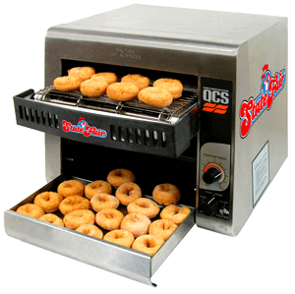 machine rents for $150
supplies
case of 420 donuts $150
20lb of cinnamon sugar mix $70
1000 bags $70

